Virtual Data Science with Python Apprentice Intern
Final Project Report
Predicting Titanic Passenger Survival: A Complete Data Science Workflow
Weeks 1–5: Data Acquisition through Strategic Recommendations
Tools: Python, Pandas, Seaborn, SciPy, Scikit-learn
Prepared by: Vandana

Executive Summary
This report brings together five weeks of work analyzing the Titanic passenger dataset (891 passengers, sourced from Kaggle), covering the full data science workflow: data cleaning, exploratory visualization, statistical hypothesis testing, predictive modelling, and strategic interpretation. The central question throughout was simple to state and rich to answer: what determined whether a passenger survived?
The analysis found that survival was not random. It was strongly and measurably shaped by who a passenger was and where they were positioned on the ship. Sex was the single strongest factor: women survived at 74.2% versus 18.9% for men, a difference confirmed as statistically significant by a chi-square test (p < 0.001, large effect size). Ticket class was the second strongest factor, with survival falling from 63.0% in 1st class to 24.2% in 3rd class (p < 0.001). These two factors, combined with age and family size, were used to train a predictive model that correctly classified 79.3% of passengers in a held-out test set, with an ROC-AUC of 0.846.
Beyond the numbers, the analysis tells a clear story of unequal access to safety during a crisis, with implications that extend well past 1912. The recommendations in Section 6 translate these findings into practical guidance for modern emergency planning, safety equity, and risk modelling.

1. Introduction

1.1 Project objective
The goal of this five-week project was to complete an entire, realistic data science workflow on one dataset, rather than practising each skill in isolation. Using the same dataset throughout meant that each week’s work built on the last: patterns noticed visually in Week 2 were tested statistically in Week 3, and the factors confirmed as significant in Week 3 became the input features for the predictive model in Week 4.

1.2 Dataset
The Titanic passenger dataset (891 rows, 12 columns) was chosen because it is public, well-documented, contains realistic data quality issues, and mixes categorical and numeric variables, making it suitable for every stage of the workflow from cleaning to modelling.

1.3 Report structure
This report follows the five weeks of work in order: methodology (data preparation, common to all weeks), exploratory findings, statistical validation, the predictive model, strategic recommendations, limitations, and a conclusion. Each section references the specific week where that work was originally carried out in full.

2. Methodology

2.1 Data preparation (Week 1)
Three data quality issues were identified and resolved. 177 missing Age values (19.9%) were filled with the median age, chosen over the mean because Age is right-skewed. 2 missing Embarked values were filled with the most common port. The Cabin column, missing for 77.1% of passengers, was dropped rather than imputed, since filling that much data would mean mostly inventing values. No duplicate rows were found.
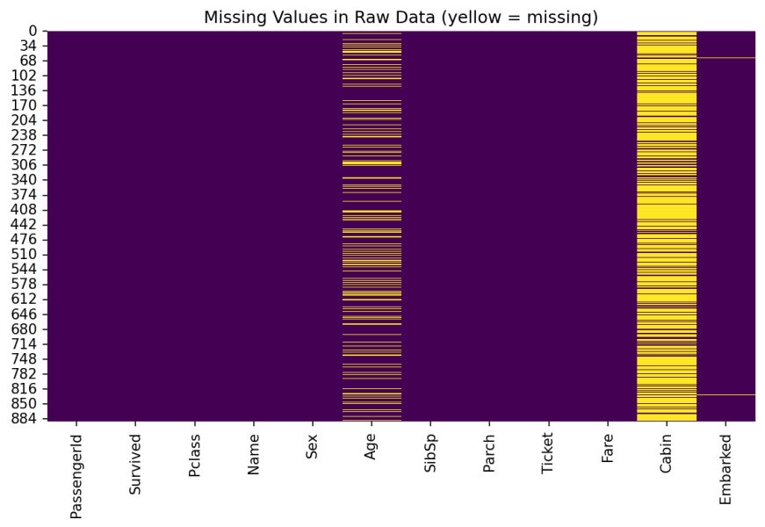
Figure 1: Missing values in the raw dataset before cleaning (from Week 1)

2.2 Feature engineering (Weeks 2 and 4)
Beyond the original columns, several derived features were created to support both storytelling and modelling: Family Size (siblings/spouses + parents/children + 1), an Is Alone flag, readable age groups (child, teen, young adult, adult, senior), and numeric encodings of sex and port of embarkation for use in the machine learning model.

2.3 Analytical approach
Week | Method | Purpose
1 | Descriptive statistics, data cleaning | Establish a clean, trustworthy dataset
2 | Visualization (bar charts, box plots, heatmaps) | Discover and communicate patterns
3 | Chi-square tests, Welch’s t-tests, ANOVA | Confirm which patterns are statistically real
4 | Logistic Regression, Decision Tree classifiers | Build a model that predicts survival from passenger data
5 | Synthesis | Combine findings into a coherent narrative and recommendations

3. Key Findings

3.1 Sex was the strongest determinant of survival (Weeks 2–3)
Women survived at 74.2% (233 of 314) compared with 18.9% for men (109 of 577). A chi-square test of independence confirmed this was not due to chance (χ² = 260.72, p < 0.001), with a large effect size (φ = 0.54).

3.2 Ticket class shaped survival, especially for women (Weeks 2–3)
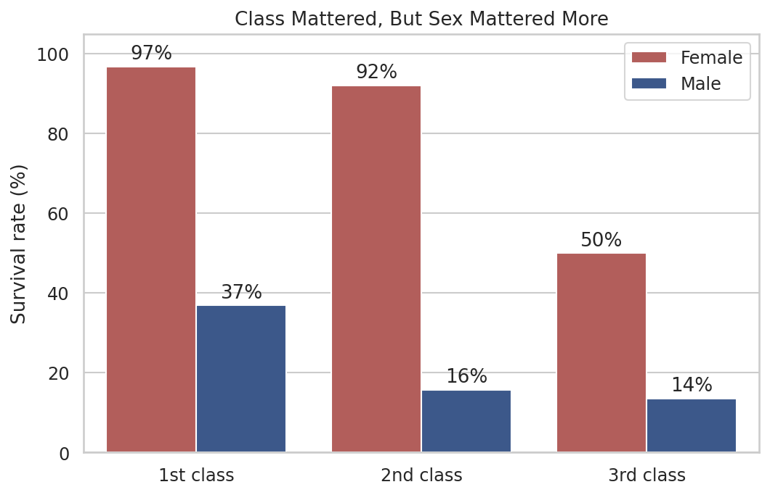
Figure 2: Survival rate by class and sex (from Week 2)
Survival fell from 63.0% in 1st class to 47.3% in 2nd and 24.2% in 3rd (χ² = 102.89, p < 0.001). The effect was strongest among women: 96.8% of 1st-class women survived versus 50.0% of 3rd-class women. Notably, women in 3rd class (50.0%) still survived more often than men in 1st class (36.9%), showing that sex mattered more than class overall, but class still mattered a great deal within each sex.
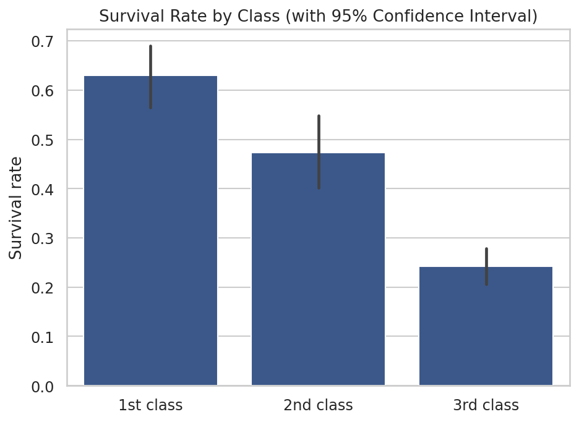
Figure 3: Survival rate by class with 95% confidence intervals (from Week 3), confirming the differences are unlikely to be due to chance

3.3 Fare, age, and family size added further explanatory power (Weeks 2–3)
- Fare: Survivors paid a higher median fare (26.00) than non-survivors (10.50), a statistically significant difference (Welch’s t-test, p < 0.001, medium effect). This mirrors the class effect, since fare and class are closely linked (correlation −0.55).
- Age: Children (0–12) had the highest survival rate of any age group (58%). The overall difference in mean age between survivors and non-survivors was not quite statistically significant (p = 0.058), suggesting the age effect is concentrated in young children rather than spread evenly across ages.
- Family size: Small families (3–4 people) survived best (61%), while solo travellers (30%) and large families (16%) fared worse, an inverted-U pattern that a simple correlation would have missed.

4. Predictive Model Performance
Building on the confirmed relationships above, two classification models were trained on 7 features (class, sex, age, fare, family size, alone flag, port) using an 80/20 train-test split and validated with 5-fold cross-validation.
Model | Test accuracy | ROC-AUC | CV mean
Logistic Regression | 79.3% | 0.846 | 79.4%
Decision Tree (depth 4) | 78.8% | 0.834 | 80.9%

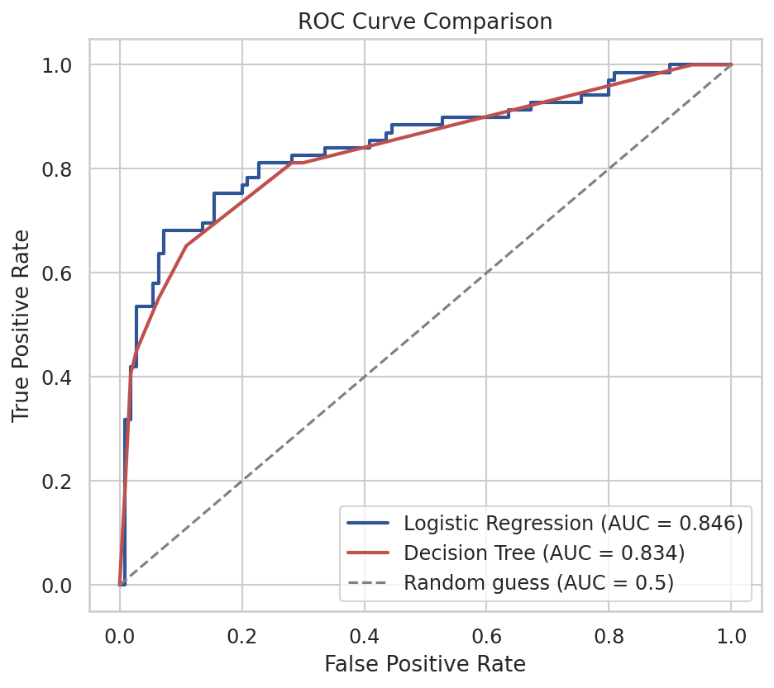
Figure 4: ROC curves for both models (from Week 4)
Both models independently ranked sex and ticket class as the two most important predictors, by a wide margin, matching the statistically significant findings from Section 3. Logistic Regression was chosen as the primary model for its balance of precision and recall and its interpretability: each feature’s effect on survival odds can be read directly from its coefficient.

5. Project Summary at a Glance
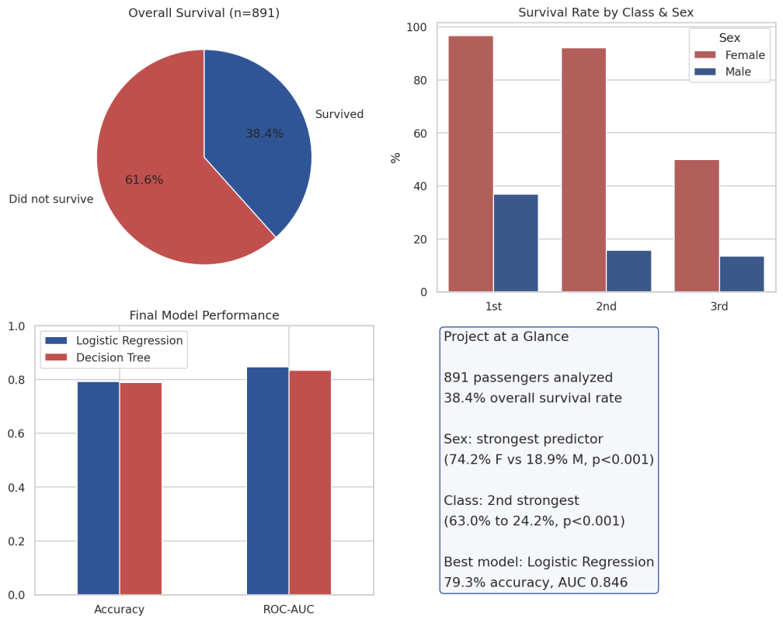
Figure 5: Summary dashboard combining the overall survival split, class/sex breakdown, and final model performance

6. Strategic Recommendations
While the Titanic sank in 1912, the pattern uncovered here (survival tied to structural position rather than individual merit) recurs in modern crisis and safety contexts. The following recommendations translate the analysis into practical guidance.

6.1 For emergency and safety planning
- Audit access equity. Any venue, ship, or building with tiered accommodation (economy vs. premium, different floors or sections) should verify that evacuation routes, safety equipment, and staff instructions reach every area equally. The 3rd-class disadvantage seen here likely reflects cabin location and access to lifeboats, not any difference in the passengers themselves.
- Prioritize vulnerable groups deliberately. The elevated survival of children reflects an active "women and children first" policy. Modern emergency protocols benefit from being similarly explicit about priority groups, rather than assuming an evacuation will naturally protect the vulnerable.
- Plan for groups, not just individuals. Small families fared best, while solo travellers and large families did worse. Evacuation planning should account for people needing to locate or coordinate with companions, and should have a clear, simple protocol for solo travellers.

6.2 For risk modelling and insurance
- Model interactions, not just individual factors. Because class and sex interact (the class effect is far larger for women than for men), a risk model using only individual variables would understate real risk concentrations. The heatmap-style analysis in Week 2 is a template for surfacing these combined effects.
- Use interpretable models where decisions must be explained. Logistic Regression’s coefficients allowed a plain-language explanation of every prediction, which matters wherever a model’s decisions need to be justified to a regulator, customer, or affected party.

6.3 For future analysis
- Extract passenger titles (Mr, Mrs, Miss, Master) from the Name column as a richer, socially-informed substitute for raw age.
- Test an ensemble model (Random Forest or Gradient Boosting), which typically improves on a single decision tree.
- Add an explicit Class × Sex interaction term to the model, since both the statistical tests and the model agree these two features matter most and interact.

7. Limitations
- The dataset covers 891 of the roughly 2,200 people aboard, so findings describe this sample rather than every passenger with certainty.
- The analysis is observational throughout; statistical significance shows a relationship is unlikely to be due to chance, not that one factor directly caused another.
- Sex, class, fare, and family size overlap considerably (for example, most solo travellers were men and most large families were in 3rd class), making it difficult to fully isolate any single factor’s independent effect.
- 177 imputed ages (set to the median, 28) add some imprecision to any age-related pattern.
- The dataset lacks information that plausibly affected survival, such as lifeboat assignment and cabin location, which likely explains why the model’s accuracy, while good, is not near-perfect.

8. Conclusion
Across five weeks, a single dataset was carried through the full data science lifecycle: cleaned and inspected, explored and visualized, tested statistically, modelled, and finally interpreted for real-world relevance. The findings were consistent at every stage. Sex and ticket class, first noticed as visual patterns in Week 2, were confirmed as statistically significant in Week 3, and turned out to be the two most influential predictors in the Week 4 model, each step reinforcing the last rather than contradicting it. The resulting model predicts survival with 79.3% accuracy from a small set of interpretable features, and the strategic recommendations in Section 6 show how a century-old dataset still offers concrete, applicable lessons for equity in modern safety and risk systems. This project demonstrates not just individual data science techniques, but how they combine into a single, evidence-based narrative from raw data to actionable insight.

Appendix: Links to Weekly Work
The complete code, data, and visualizations for each week are available in the accompanying GitHub repository, organized by week:
- Week 1: Data acquisition, cleaning, and exploratory analysis (week1.py)
- Week 2: Advanced visualization and storytelling (week2.py)
- Week 3: Statistical analysis and hypothesis testing (week3.py)
- Week 4: Machine learning model development and evaluation (week4.py)
- Week 5: This report and its summary dashboard (week5_summary.py)

